|  |  |  |  |
| --- | --- | --- | --- |
| Version | Date | Author | Comments |
| 1.0 | Aug-18-2016 | Deepshika | Create a document |
|  |  |  |  |
|  |  |  |  |

FUNCTIONAL SPECS

for

Local Conveyance Tracking

# 0 ) Target Release

V1.0

# 0.1 ) Internal Availability Target date:

Aug 24, 2016

# 0.2 ) Actual Internal Availability date:

Aug 31, 2016

# 1 )Overview

Currently maintaining/entering/updating conveyance form is done only manually where in there is no system to maintain conveyance form through online. We need to provide them a system where conveyance form can be filled through on line by logging into the portal.

# 2 ) Functional Description

Currently maintaining conveyance form is done manually

However we need to provide a system that maintains the conveyance form

for the user.

* When Employee logs in he/she can
* Enter a new LCF
* View LCF that is entered.
* When Manager logs in he/she can
* Enter a new LCF
* View his/her form
* View the LCF that is entered by their direct subordinate. After viewing the LCF’s of their direct subordinates he/she can do any one of the following
* Approve the LCF’s made by the direct subordinates.
* Reject the LCF’s made by the direct subordinates.
* When Finance people logs in he/she can
* Enter a new LCF
* View his/her form
* View LCF that is made visible by the Manager
* After viewing the LCF’s that is processed by the Manager he/she can do any of the following
* Approve it and return their transactions
* Reject the LCF if he/she is not satisfied with the information they provided
* When Admin logs in
* Enter a new LCF
* Views his/her LCF
* Maintains the Master (i.e.) Mode of Travel
* Add a travel mode
* Edit a travel mode
* Remove a travel mode

Now after logging into the System the User can View their profile to log out from the Portal.

# 3 ) Detailed Functional Description with applicable use cases

* **Login Page**
* When the user needs to go to the Portal he/she must log in into the login Page as shown in the fig.1.0

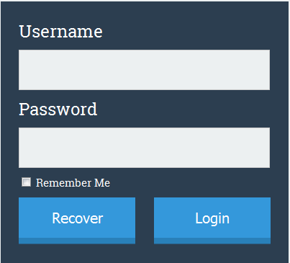

Fig.1.0

(Recover : when the user forgets the password they can retrieve/will be given password to relogin again)

* When the user enters the username and forgets to enter the password/wrong password is typed, and logs in he/she will get an alert message as shown in the fig.1.1

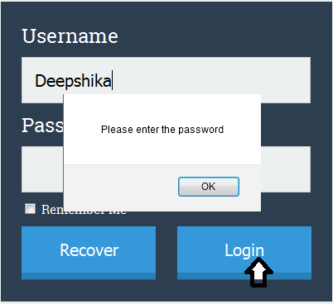

Fig.1.1

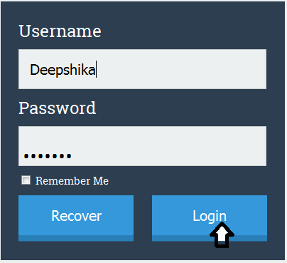

Fig.1.2

* After entering the correct username and password the next home page appears as shown in the fig.2.0



Fig.2.0

* **View Icon**
  + On click of the view button the user can view their entered LCF’s.
* **Create a New LCF**
* When the user clicks on the create a new LCF, the LCF is displayed as shown in the fig.3.0

|  |  |  |  |  |  |  |  |  |  |
| --- | --- | --- | --- | --- | --- | --- | --- | --- | --- |
| EDS TECHNOLOGIES PRIVATE LIMITED  Regd : The Estate, Second floor,121,Dicenson Road, Bangalore – 560042,INDIA  Tel : 49190333, 25514338 Fax : 49190399  Name : Deepshika Region : Bangalore  Designation : GET Employee Code : 911023  Travel Plan : C Department : Technical  Statement of Conveyance Expenditure for the month of ____ | | | | | | | | | |
| **S.No** | **Date** | **Particulars** | | **Depart.**  **At** | **Arrive By** | **Distance in Kms** | **Mode** | **Amount** | |
| **From** | **To** | **Rs** | **Ps** |
|  |  |  |  |  |  |  |  |  |  |
| **Attach** | | Total | | | | | |  |  |
| In Words :  Please reimburse the above expenditure incurred by me.  Date : 25/08/2016 Approved By : Payment Ref :  A/C Dept : | | | | | | | | | |

Fig.3.0

* The details of the user are fetched from the Database Table(external system) as shown below.

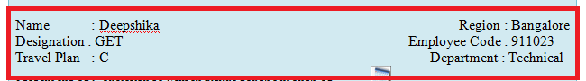

* **After the LCF’s is displayed the user need to Start entering the details in the form**
* Pick the month/year from the calendar button as shown in the fig.3.1





Fig.3.1

* Enter the travel details(location) in From and To column of LCF’s form.
* Enter the distance travelled in Kms.
* In the Drop Mode list select the mode of travel as shown in the fig.3.0.2

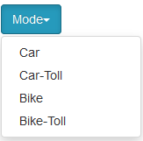

Fig.3.2

* Once the Travel mode is selected the amount is calculated automatically by the computer by default(for ex: car Rs.10/km, bike Rs.8/km etc..)
* The calculated amount is also displayed in words manually by the System.
* The date is displayed automatically by the system once the user enter their details in the LCF.
* **When any of the fields is not entered in the LCF, an alert message is thrown on Click of the Submit Button.**

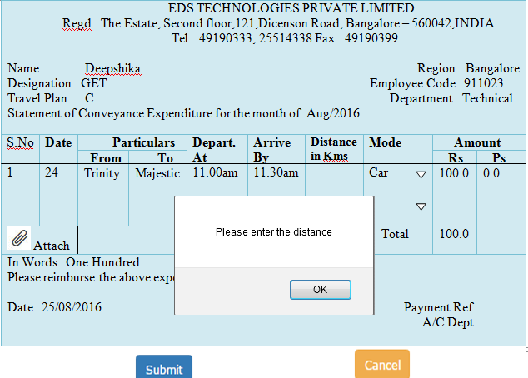

Fig.3.3

* **After entering the details, user saves the transaction by On Click of the Submit Button.**

|  |  |  |  |  |  |  |  |  |  |
| --- | --- | --- | --- | --- | --- | --- | --- | --- | --- |
| EDS TECHNOLOGIES PRIVATE LIMITED  Regd : The Estate, Second floor,121,Dicenson Road, Bangalore – 560042,INDIA  Tel : 49190333, 25514338 Fax : 49190399  Name : Deepshika Region : Bangalore  Designation : GET Employee Code : 911023  Travel Plan : C Department : Technical  Statement of Conveyance Expenditure for the month of Aug/2016 | | | | | | | | | |
| **S.No**  1 | **Date**  24 | **Particulars** | | **Depart.**  **At**  11.00am | **Arrive By**  11.30am | **Distance in Kms**  10 | **Mode**  Car | **Amount** | |
| **From**  Trinity | **To**  Majestic | **Rs**  100.0 | **Ps**  0.0 |
|  |  |  |  |  |  |  |  |  |  |
| Attach | | Total | | | | | | 100.0 |  |
| In Words : One Hundred  Please reimburse the above expenditure incurred by me.  Date : 25/08/2016 Approved By : Payment Ref :  A/C Dept : | | | | | | | | | |

 

Fig.3.4

* + After entering the details the user can Submit the LCF .Once the user Submits the LCF he/she cannot modify the form, incase if the user does not want to submit the form they can click on the Cancel Button.
  + On Click of the Submit button the form is made visible to their respective Manager.
* **As soon as when the Manager logs into the Portal he/she can view this page**



Fig.4.0

* On Click of create a new LCF button the LCF form is displayed.
* On Click of View my LCF button, the Manager views his/her own LCF.
* On Click of View Others button, the Manager Views the LCF’s of their direct subordinates as shown in the fig.

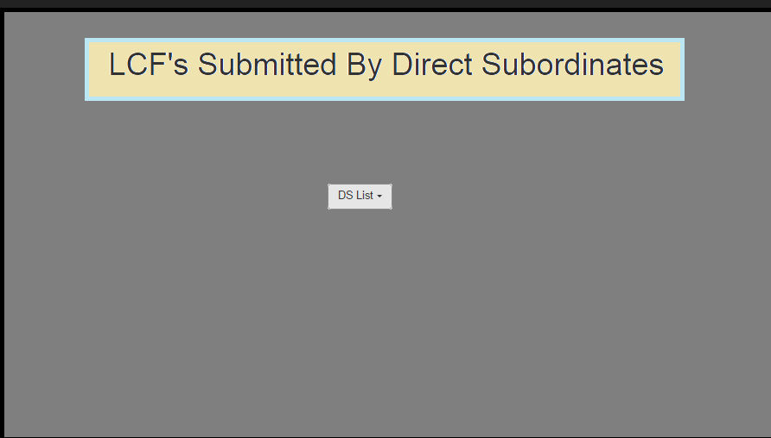

* On Click of DS drop list, a list of employees name who have applied for LCF’s will be displayed. On Click of particular employee a check box of pending and approved status will be shown as shown in the fig.

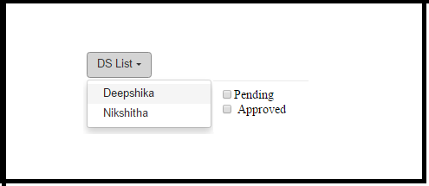

* On Click of Pending/Approved Check box a LCF’s table will be shown as shown in the fig.

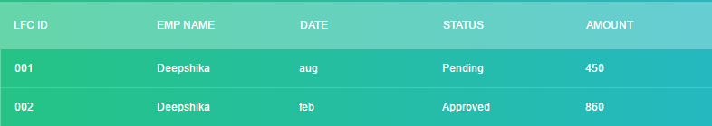

* To know the details of the pending list in the table the Manager clicks on a row in the table where LFC ID is 001 and the details are as shown in the below.

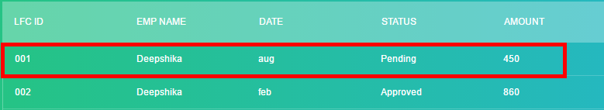

|  |  |  |  |  |  |  |  |  |  |
| --- | --- | --- | --- | --- | --- | --- | --- | --- | --- |
| EDS TECHNOLOGIES PRIVATE LIMITED  Regd : The Estate, Second floor,121,Dicenson Road, Bangalore – 560042,INDIA  Tel : 49190333, 25514338 Fax : 49190399  Name : Deepshika Region : Bangalore  Designation : GET Employee Code : 911023  Travel Plan : C Department : Technical  Statement of Conveyance Expenditure for the month of Aug/2016 | | | | | | | | | |
| **S.No**  1 | **Date**  24 | **Particulars** | | **Depart.**  **At**  11.00am | **Arrive By**  11.30am | **Distance in Kms**  10 | **Mode**  Car | **Amount** | |
| **From**  Trinity | **To**  Majestic | **Rs**  100.0 | **Ps**  0.0 |
|  |  |  |  |  |  |  |  |  |  |
| Attach | | Total | | | | | | 100.0 |  |
|  | | | | | | | | | |

 

Fig.4.1

The Manager should write his/her name(only after accepting their direct subordinate form) in the Approved By field after the submission of LCF made by the direct subordinate.

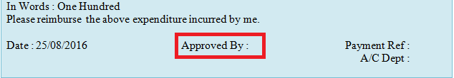

After the Approval of the Manager, the status is changed automatically in the table as shown below and it is made visible to the Finance Department by the Manager.

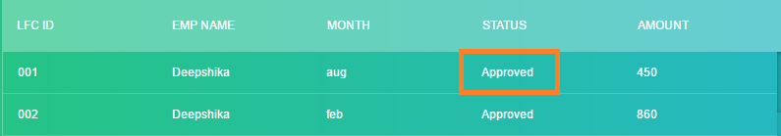

* **When the Finance Person logs into the Portal, a Home Page is Displayed as shown in the fig.**



Fig.5.0

* On Click of create a new LCF button the LCF form is displayed.
* On Click of View my LCF button, the Finance Person views his/her own LCF.
* On Click of View Others button, the Finance Person Views the LCF’s that is made visible by the Manger.

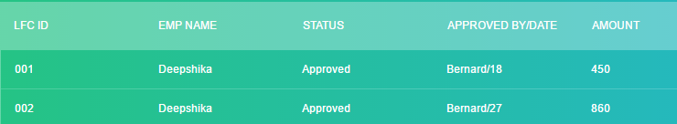

* If the Finance Person has to know the details of the particular employee he/she clicks on the particular row in the table.

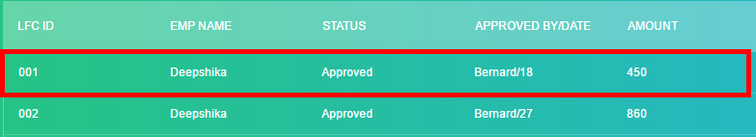

* On click of the particular row the Finance Person gets the entire details of the Employees LFC’s.
* On viewing the details The Finance Person has the rights to either accept/reject their request.

|  |  |  |  |  |  |  |  |  |  |
| --- | --- | --- | --- | --- | --- | --- | --- | --- | --- |
| EDS TECHNOLOGIES PRIVATE LIMITED  Regd : The Estate, Second floor,121,Dicenson Road, Bangalore – 560042,INDIA  Tel : 49190333, 25514338 Fax : 49190399  Name : Deepshika Region : Bangalore  Designation : GET Employee Code : 911023  Travel Plan : C Department : Technical  Statement of Conveyance Expenditure for the month of Aug/2016 | | | | | | | | | |
| S.No  1 | **Date**  24 | **Particulars** | | **Depart.**  **At**  11.00am | **Arrive By**  11.30am | **Distance in Kms**  10 | **Mode**  Car | **Amount** | |
| **From**  Trinity | **To**  Majestic | **Rs**  100.0 | **Ps**  0.0 |
|  |  |  |  |  |  |  |  |  |  |
| Attach | | Total | | | | | | 100.0 |  |
| In Words : One Hundred  Please reimburse the above expenditure incurred by me.  Date : 25/08/2016 Approved By : Bernard Payment Ref :  A/C Dept : | | | | | | | | | |

 

Fig.5.1

After LCF’s is accepted by the Finance Department the “Payment Ref” num is entered in the form and the amount is released to the employees.

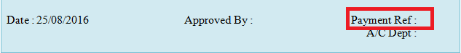

The Account Department Manager should write his/her name(only after accepting the LCF forwarded by their respective Manager) in the A/C Dept field after verifying the details.

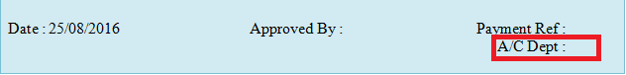

* **Admin has the rights to add/remove/edit the Travel mode list**

 On Click of add button the admin can add a new travel mode.

On Click of remove button the admin can remove the travel mode.

 On Click of edit button the admin can edit the travel mode.

**Report:**

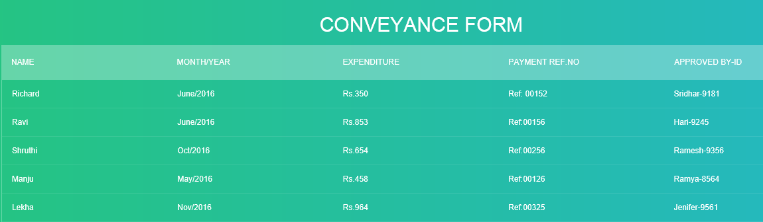

**Work-Flow**

Employee Logs In

Views their own LCF

Create a new LCF

Fills the LCF

Submits

Manager Logs In

Views Other User LCF(made visible by Direct subordinates)

Views their own LCF

Create a new LCF

Fills the LCF

Reject

Accept

Submits

Finance User Logs in

Views Other User LCF(made visible by Manager)

Views their own LCF

Create a new LCF

Print

Accept

Fills the LCF

Submits

Admin Logs In

Modify(Travel Mode)

Views their own LCF

Create a new LCF

Fills the LCF

Remove

Edit

Add

Submit

# 4 ) Definition/Glossary

LCF – Local Conveyance Form.

DS – Direct Subordinates.

# 8 ) Reviewed By

|  |  |  |
| --- | --- | --- |
| Reiewed By | Date | Comments |
| xxx | dd-mmm-yy |  |
|  |  |  |
|  |  |  |

# 9 ) Product Documentation/Help update

|  |  |  |
| --- | --- | --- |
| By | Date | Comments |
| xxx | dd-mmm-yy |  |
|  |  |  |
|  |  |  |